**Name:- Patel Ayush Padminkumar**

**Branch:- Cyber Security (13)**

**Enrollment no:- CS 32**

**Practical-1**

**To study about Webpage and its Tags.**

**Exercise-1**

**Create a webpage which contains image of computer as a link. When click on the image**

**a new webpage is open which give information of parts of computer.**

**Code:-**

<html>

<head><center><h1 style="color:whitesmoke;">Information of Computer Parts</h1></center>

<title>5.1</title>

</head>

<style>

body

{

background-image:url('https://imgs.search.brave.com/dFXkCEC3thxoUl3whQTD7ZZrCzPLGRpBS4ZzRV78x9E/rs:fit:1200:1200:1/g:ce/aHR0cHM6Ly93YWxs/cGFwZXJjYXZlLmNv/bS93cC8zalFib25P/LmpwZw');

background-size:cover;

background-repeat: no-repeat;

background-attachment: fixed;

}

</style>

<body><center>

<table>

<tr><td>

<a href="https://www.computerhope.com/jargon/m/mothboar.htm" target="_blank">

<img alt="motherboard" src="MB.jpg" height="200px" width="300px"></a><h2 style="color: whitesmoke;" align="center">Motherboard</h2></td>

<td><a href="https://www.computerhope.com/jargon/r/ram.htm" target="_blank">

<img alt="RAM" src="th.jpg" height="200px" width="300px">

</a><h2 style="color: whitesmoke;" align="center">RAM</h2></td>

<td><a href="https://www.computerhope.com/jargon/g/gpu.htm" target="_blank">

<img alt="GPU" src="GPU.jpg" height="200px" width="300px"></a><h2 style="color: whitesmoke;" align="center">GPU</h2>

</td>

</tr>

<tr>

<td><a href="https://www.computerhope.com/jargon/h/harddriv.htm" target="_blank">

<img alt="SSD" src="ssd.jpg" height="200px" width="300px"></a><h2 style="color: whitesmoke;" align="center">Hard disk</h2>

</td>

<td>

<a href="https://www.computerhope.com/jargon/c/cpu.htm" target="_blank">

<img alt="cpu" src="cpu.jpg" height="200px" width="300px">

</a><h2 style="color: whitesmoke;" align="center">CPU</h2>

</td>

<td>

<a href="https://www.computerhope.com/jargon/p/power-supply.htm" target="_blank">

<img alt="PSU" src="psu.jpg" height="200px" width="300px">

</a><h2 style="color: whitesmoke;" align="center">Power Supply Unit</h2>

</td>

</tr>

</table>

</center>

</body>

</html>

**Output:-**

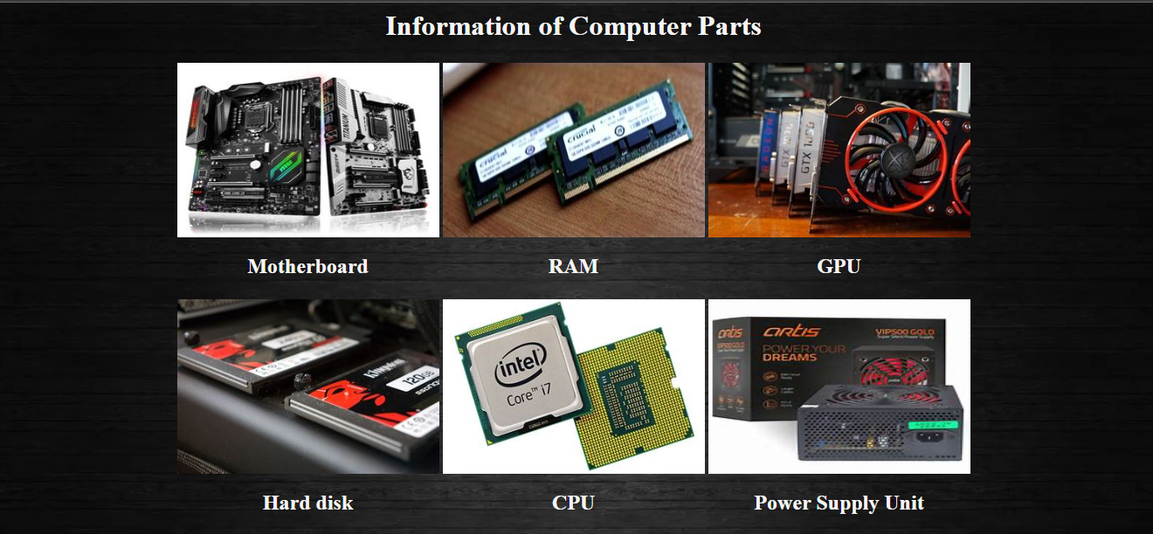

**After clicking images:-**

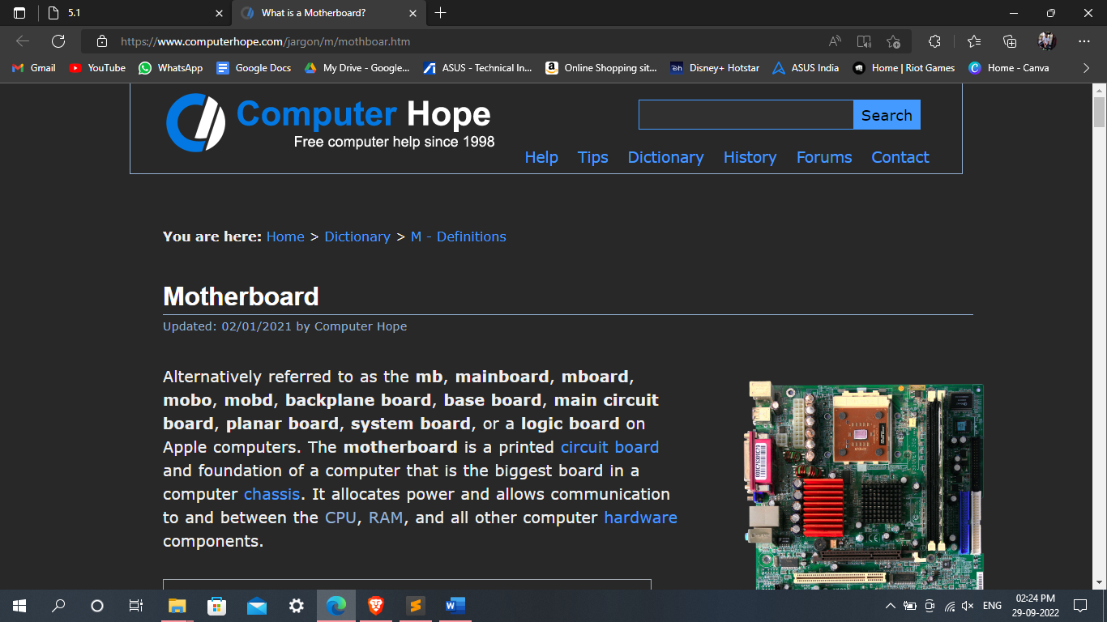

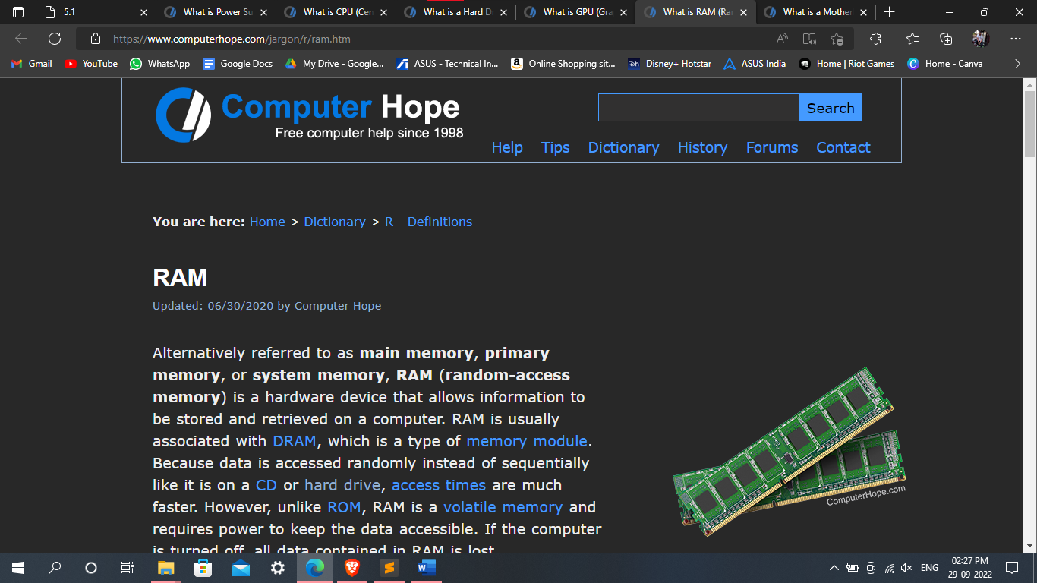

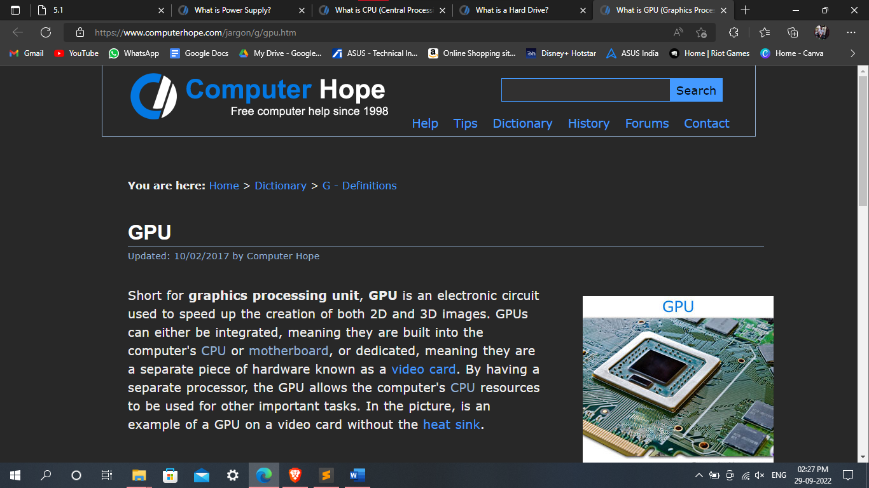

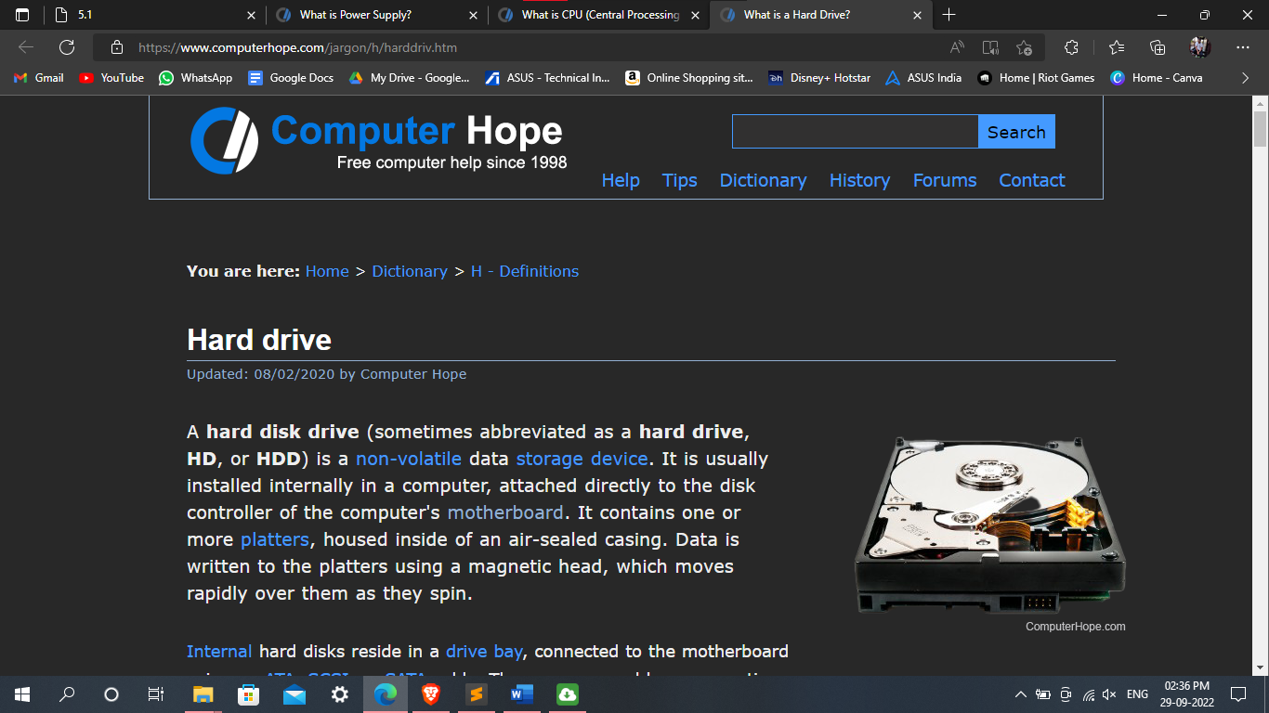

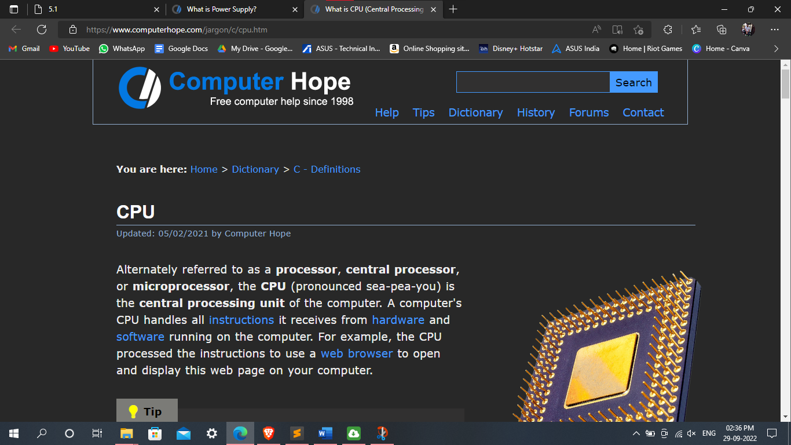

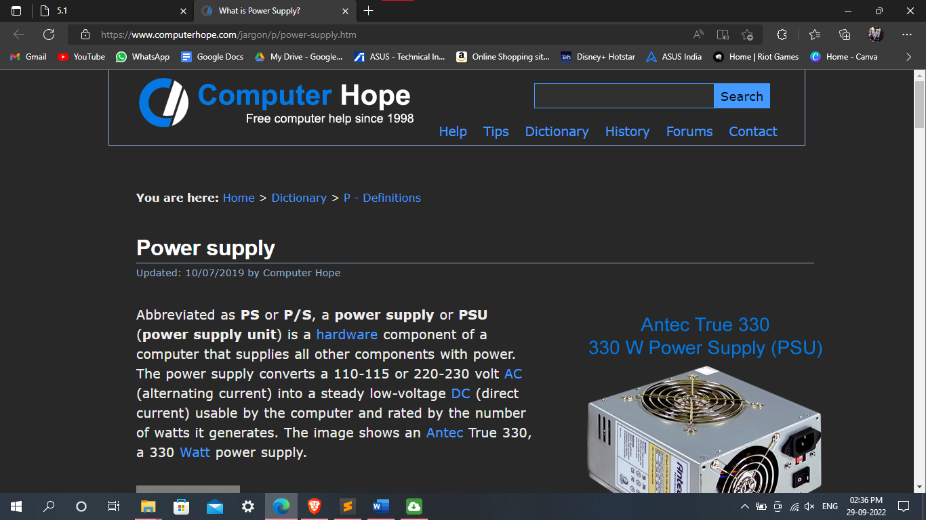

**Exercise-2:**

**Create a webpage which shows all the attribute of hr tag with its description.**

**Code:-**

<html>

<head>

<style>

body{

background: url(ayush.webp);

}

</style>

<title>Practical 5.2</title>

</head>

<body>

<center>

<h2 style="font-size: 30px; color: whitesmoke;"><u>HR TAG</u></h2>

<h4 style="font-size: 20px;">Hr tag is used to display a line.</h4>

</center>

<br><br>

<h4 style="font-size: 20px; color: orangered;"><u>Attributes of HR tag:-</u></h4>

<ol>

<li>Width:-

<ul>

<li>It is used to define the width of the line.</li>

</ul>

</li>

<li>Size:-

<ul>

<li>It is used to define the size of the line.</li>

</ul>

</li>

<li>color:-

<ul>

<li>It is used to define the color of the line.</li>

</ul>

</li>

<li>algin:-

<ul>

<li>It is used to define the alignement of the line.</li>

</ul>

</li>

<li>Border-radius:-

<ul>

<li>It is used to define the border radius of the line.</li>

</ul>

</li>

</ol>

</body>

</html>

**Output:-**

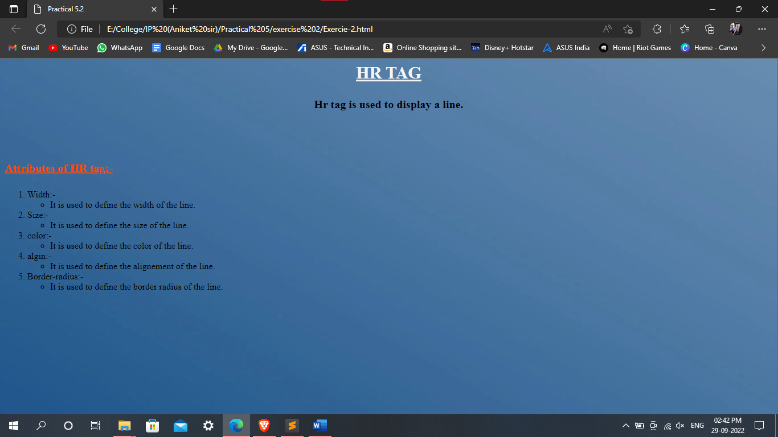

**Exercise-3:-**

**Create a webpage which shows following output.**

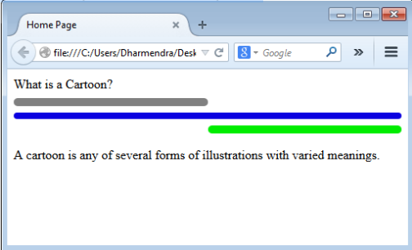

**Code:-**

<html>

<head>

<title>hr tag</title>

</head>

<body>

<p style="font-size: 30px;">What is a Cartoon?</p>

<hr style="border-radius: 100px;" color="grey" width="50%" align="left" size="10" />

<hr style="border-radius: 100px;" color="blue" width="100%" size="10" />

<hr style="border-radius: 100px;" color="green" width="50%" align="right" size="10" />

<p style="font-size: 30px;">A cartoon is any of several forms of illustrations with varied meanings.</p>

</body>

</html>

Output:-

